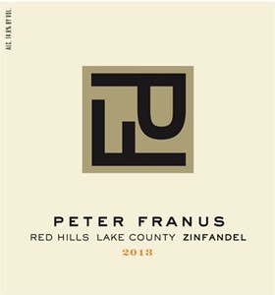
2013 Red Hills Zinfandel
Lake County

Twelve years ago, well before many were seriously considering the potential of Lake County, one of my best growers, Jim Fore, took a gamble and purchased property on the top of Cobb Mountain. The vineyard site is located a few miles east of Sonoma County and a dozen miles north of Napa Valley's Calistoga.

This is a spectacular property, situated at 3000 feet elevation. Soils are thin in the Red Hills and drain instantly. The elevation places vines well above the hot summer heat trapped in the valleys below, and aligns them in the path of cool westerly Pacific breezes. At the same time, there is paradoxically greater solar intensity that has some magical and perhaps inexplicable effect on the grapes. Because of the high elevation, the differential between day and night time temperatures is dramatic. This results in grapes with intense flavor and color development. This is unquestionably one of the most beautiful and peaceful vineyard sites I have ever worked with.

As time went on, I gained a finer insight into the growing conditions of the region and began to compare it to those of the Napa Valley. Perhaps most similar is Mount Veeder, located in the western mountain range dividing Napa and Sonoma Valleys. Of particular note, Mount Veeder is home to arguably our flagship wine, Brandlin Vineyard Zinfandel. So we gambled again and planted two old clones of Zinfandel, River One and Mead Ranch, and harvested our first crop in 2012. Our intuition proved to be correct!

After the marvelous 2012 vintage, we were rewarded again in 2013, with a nearly perfect growing season, and a long ripening period as well. I refer to it a “leisurely” harvest, not forced to pick for fear of rain or extreme heat. When the winemaker is relaxed, so is the wine!

Our 2013 Red Hills Zinfandel is medium ruby in color and offers notes of white pepper, herb, allspice, and raspberry. Aromas lead to similar flavors in a lively and refreshing structure not often seen in this variety. This is an easy, palatable ode to classic Zinfandel!
Red Hills is clearly destined to become one of the premier Zinfandel regions in California.

