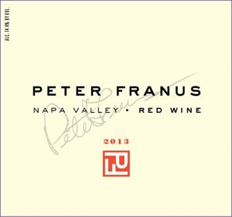
2013 Napa Valley Red
Bordeaux Blend

I am attracted to wines that are elusive. For me the most exciting wines are the ones you can’t quite put a finger on. They draw you back, each time offering something a little different. You could say that is my inspiration for our Napa Valley Red, a blend of Cabernet Sauvignon, Merlot, and Cabernet Franc. Cabernet Sauvignon is of course the driving force in Napa Valley, and there are plenty of big, powerful Cabs out there. But in our quest for nuance, complexity, and intrigue, our Napa Valley Red pays homage to that artistic side of winemaking--blending!

One of the regions of Bordeaux that attracts me the most is St. Julien. Wines from the region are typically graceful, elegant, and in a sense, gentle. And guess what? Although Cabernet Sauvignon typically provides the backbone, a third or more is usually made up of Merlot and Cabernet Franc.

My sources for Cabernet Sauvignon are superb—two organic vineyards, one on Howell Mountain and the other in St. Helena. I have the good fortune to work with some top notch Merlot and Cabernet Franc, both coming out of Carneros. Each stands well on its own, but when blended together, the resulting wine offers a unique and different experience. With more than 30 years of winemaking in Napa Valley, intuition guides me as I select a handful of barrels—ten to be precise—to compose this final blend.

After the marvelous 2012 vintage, we were rewarded again in 2013, with a nearly perfect growing season, and a long ripening period as well. I refer to it a “leisurely” harvest, not forced to pick for fear of rain or extreme heat. For me a relaxed harvest is often an indicator of a fabulous vintage.

As for the wine, although virtually opaque, it is vibrant and lively, never ponderous. Classic and pretty notes of cassis, dried herb, white pepper, vanilla and sweet oak emerge, leading to an expansive and structured mouth. It excites the palate and its persistence slowly sneaks up on you, hinting at the wonderful experience it will also offer in the future. Tannins are appropriate and integrated in this impeccably balanced wine.

This is the sixth Napa Valley Red we have done over the years. Is it the best? Maybe!!

